TMT/Gurugram /S0821/2026 26-06-2026

To,
Phool Chand
Honda Motorcycle And Scooter India Pvt. Ltd. Gurugram - 122050, HR
+91-8130299513
E-mail: pcnishad2007@rediffmail.com

Dear sir,

Sub: Roll Forming Machine with 11 passes with door frame section tooling.

Thank you very much for your enquiry regarding your requirement of door frame section tooling roll forming machine with cutting unit. We are glad to inform you that we would be in a position to supply you the required system. Given below are the required specifications and description of the machine and our terms and conditions.
Prices
The cost of door frame roll forming machine along with EN 31 tooling also with 20 Hp motor is Rs 18,00,000 (Eighteen Lakhs Only)
LIST OT EQUIPMENT
- MANUAL DE COILER 3 TON CAPACITY
- ROLL FORMING MACHINE WITH DRIVE
- 20 HP DRIVE WITH 3 NUMBERS RUDUCTION GEARBOXS.
- COMPLETE ELECTRICALS
- POST CUTTING PRESS WITH V EDGE CUTTING TOOL

Technical specifications:
MANDREL UNCOILER

Model : Single arm

Coil weight : 3 Ton Max

Material thickness : 0.5-3.0 MM

Coil width : 350 MM max

Coil bore : dia 450 MM min, 550 MM max

Coil Od : 1500 MM (max)

Mandrel movement : Manual

Construction : M. S. Fabricated.

:
MAIN ROLL FORMING MILL

Maximum sheet width that can be formed : 350 MM

Maximum sheet thickness in MS that can be formed : 1.6 MM

Minimum sheet thickness in MS that can be formed : 1.0 MM

Roll shaft diameter : dia 60 MM

The vertical distance between shafts : 250 MM

The horizontal distance between shafts : 410 MM

Number of forming stations : 14 Nos

Drive (AC) : 20 HP

Speed of the machine : 15 meters/max

Description of the equipment
Roll Forming Machine
Main Base
The main base is MS fabricated structure and adequately ribbed to minimize the distortion. It is accurately machined on top and bottom surfaces the threaded holes are made on the bed for positioning the stands.
Entry Guide
The entry side of the machine will be equipped with guide table and the guide wheels bar which will be responsible for centering the leading ends of the strip into the first pass.

Roll shafts
The roll shafts will be manufactured from quality steel and will be keyed to locate tooling.
Drive
The drive to the roll former will be by means of a gear box system. The main drive will be provided by means of 15 HP motor. The speed of the roll former is fixed.

Main mill : 20 HP
Power pack : 5 HP
----------------------------
TOTAL HP : 25 HP
------------------------------
Cutoff unit
The cutoff unit with 40 Ton hydraulic press with table 350x250x300mm (LxWxH).
GENERAL TERMS & CONDITIONS:

- Price quoted per unit ex-work. Hyderabad.
- Following charges are additional to your account.
- Freight Charge : As actual to be borne by you.
- Excise : Extra As Applicable
- Sales Tax : Extra as applicable
- Packing charge : As actual to be borne by you.
- Insurance : As actual to be borne by you.
- Payment : 50% advance along with order balance before delivery but after inspection at our works.
- Delivery : Within 15 months from date of advance received
- Validity : One month from the date of submission.
- Inspection : Inspection at our works prior to dispatch.
- Warranty : The machine is warranted for a period of 12 months from the date of dispatch against any manufacturing defects/ faulty material or bad workmanship of any part or component but not against any kind of abnormal or improper use of machine. Defective part or component will be replaced or repaired free of cost. Electrical components are outside the scope of this warranty.
- Commissioning : Erection & commissioning done by you, but required technical support & guidance provide by us at additional cost.

NOTE:
- Oil is not in scope of our supply.
- Raw material for trial is to be arranged by you at your cost.

We are sure you will find our offer in line with your requirements. Should you require any further clarification please contact t.sivaramakrishna 9246221106.
Email : srktalam@gmail.com

Thanking you and assuring you of our best services.

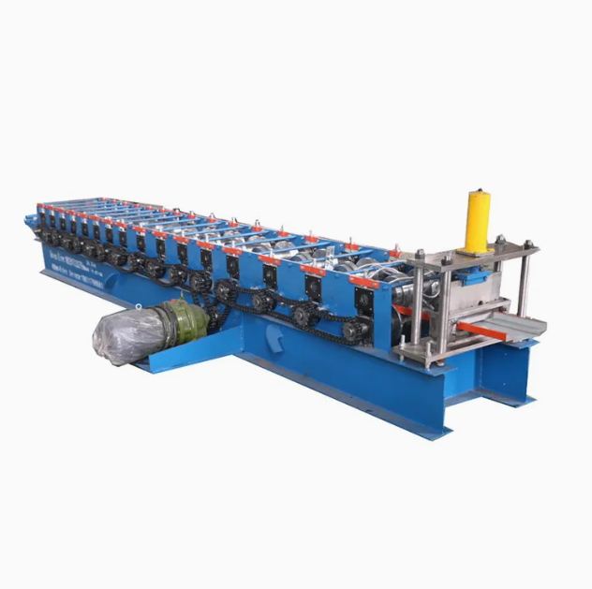



For TECHNO MACHINE TOOLS

(T.SIVARAMAKRISHNA)

